2.DESIGN AND CONFIGURATION OF STAR TOPOLOGIES USING PACKET TRACER.

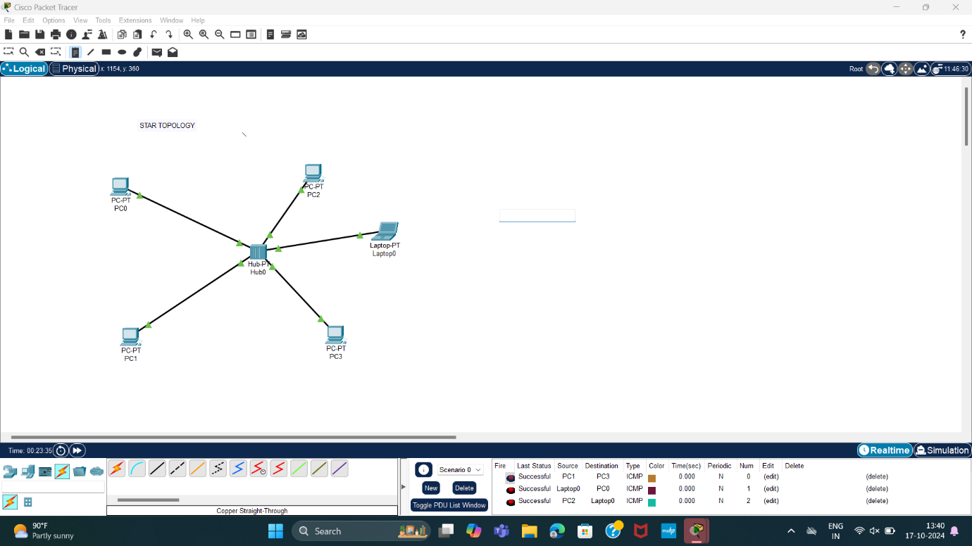

3.DESIGN AND CONFIGURATION OF BUS TOPOLOGIES USING PACKET TRACER.

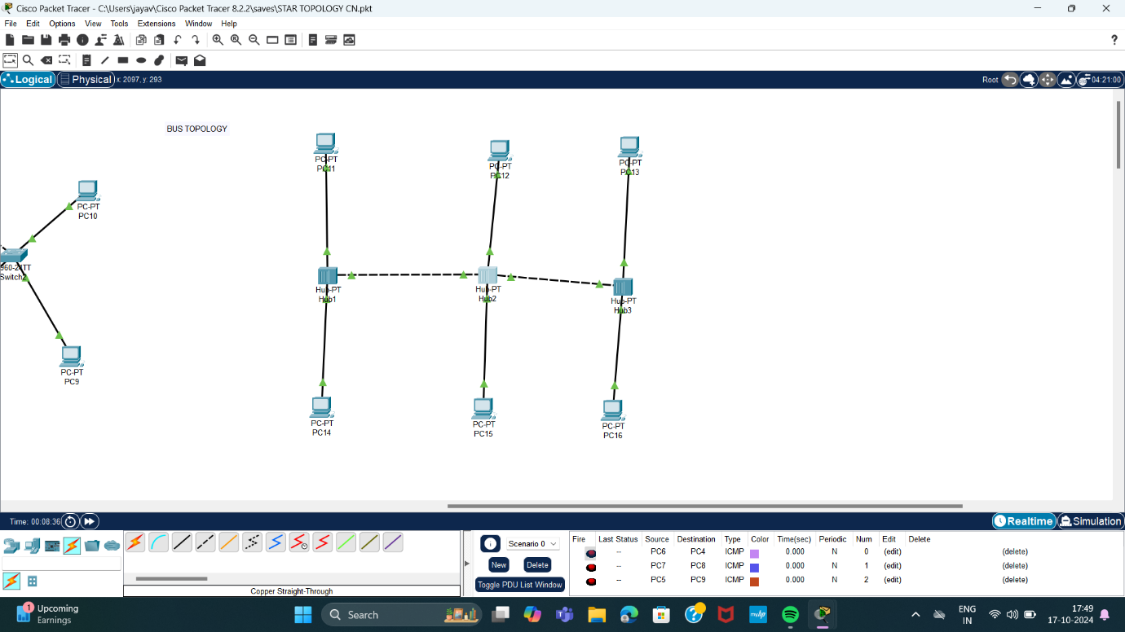

4.DESIGN AND CONFIGURATION OF MESH TOPOLOGIES USING PACKET TRACER.

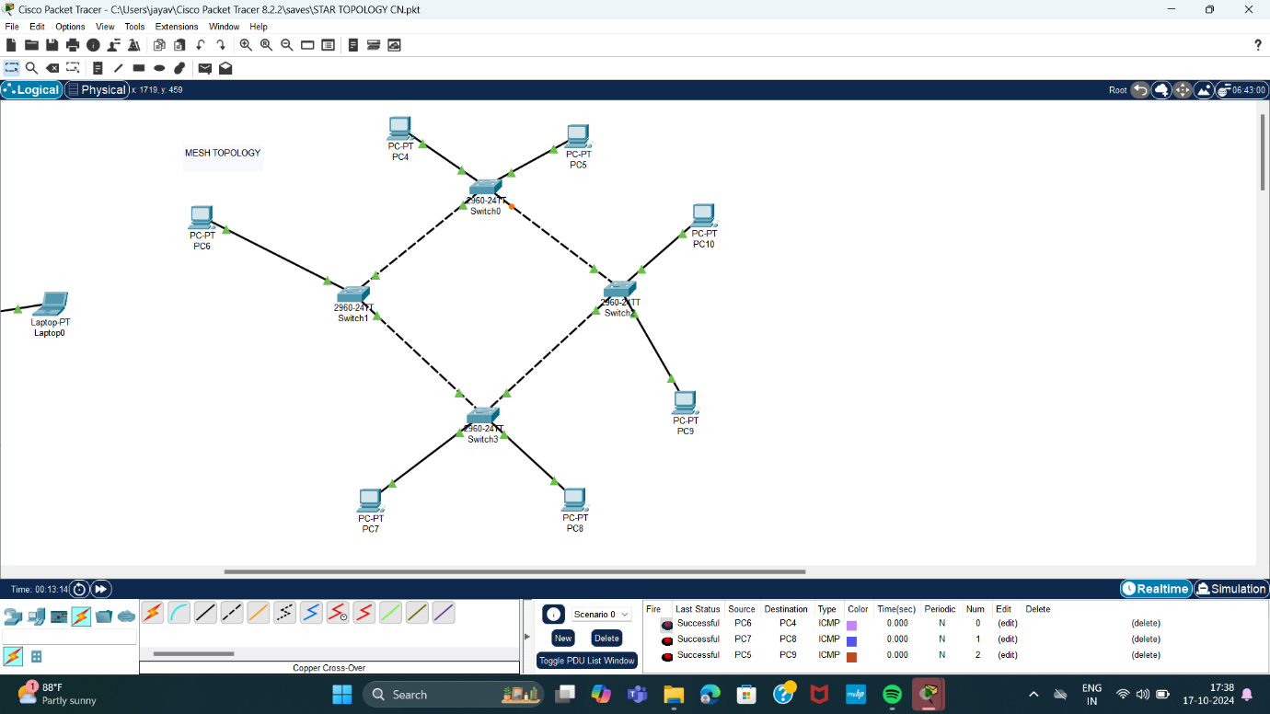

5.DESIGN AND CONFIGURATION OF HYBRID TOPOLOGIES USING PACKET TRACER

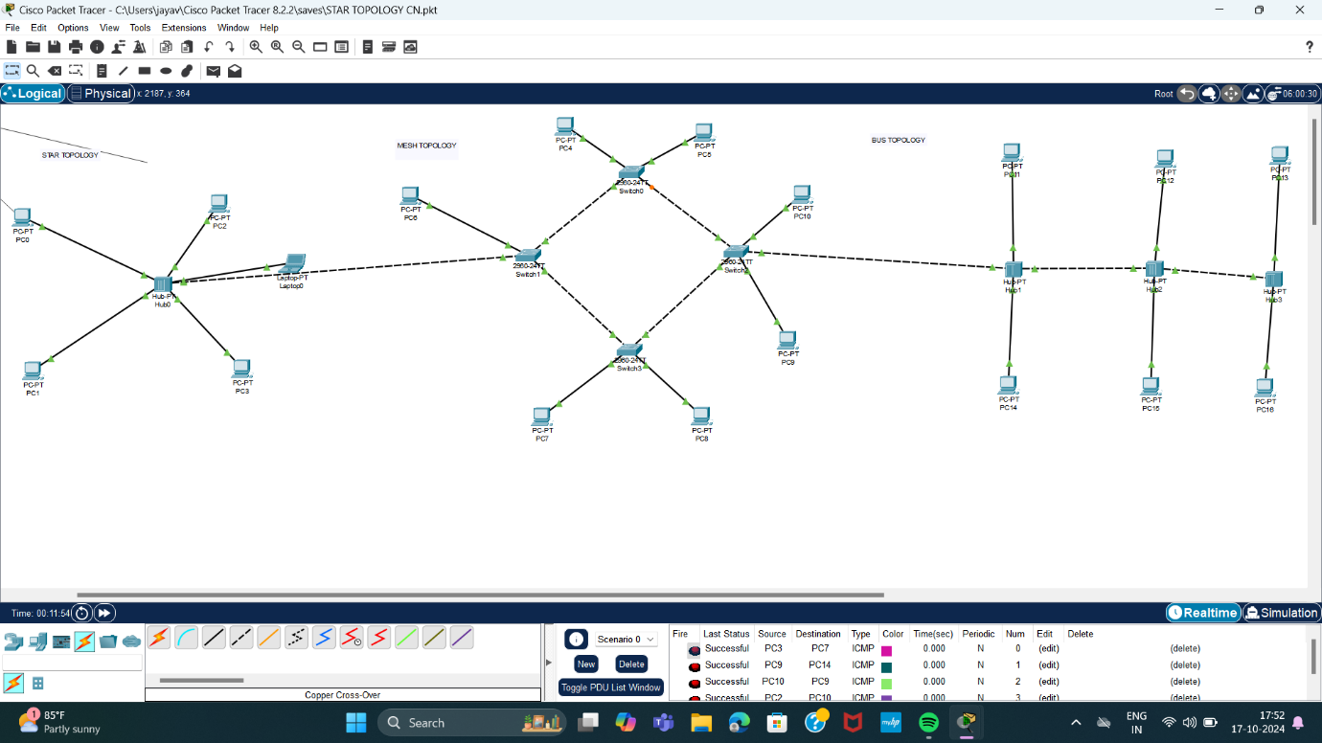

6.DESIGN AND CONFIGURATION OF TREE TOPOLOGIES USING PACKET TRACER.

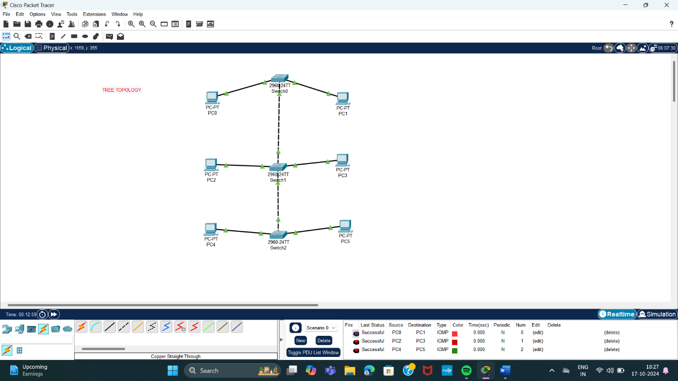

7.DESIGN AND CONFIGURATION OF RING TOPOLOGIES USJNG PACKET.

